Alaska,

Running the debugger via the workbench often yields the following error:

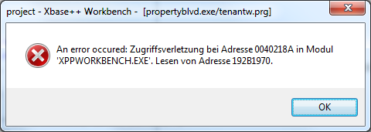

The workbench then annoyingly wipes out the entire PRG and the following error appears:

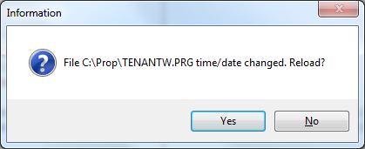

Then the first error endlessly pops-up with the only option to terminate the program via the task-manager.

Can this be fixed soon?

Many thanks,

-Itai