Our stuff, all gets created by the same procedure

Drawingarea readable and unreadable
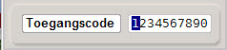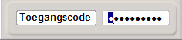

TabPage readable and unreadable (count the dots)
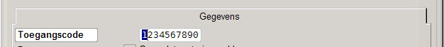

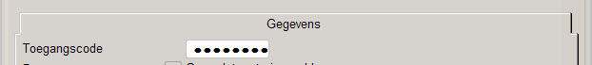

Basic Xbase
